Steam Games Dataset
Team Members:
Isaac Darlington, Alex Solomon, Diego Trevino

Introduction
Dataset description: This dataset includes data on over 110,000 different games on the steam gaming platform that includes things like the release date, estimated owners, peak concurrent players (CCU), price, DLC, game reviews, and supported languages. Some of the things we could explore with this data set might include stuff like what game was the most popular during certain years with the peak CCU, how popular games were during the first month of their initial release compared to now, or how having more supported languages might influence how many players downloaded and/or played the game.
Results
[Part1: Genres and Tags] for Isaac Darlington
[Question1]: What genre categories have the highest average user playtime? (Average Playtime Forever vs. Average playtime Last 2 Weeks).
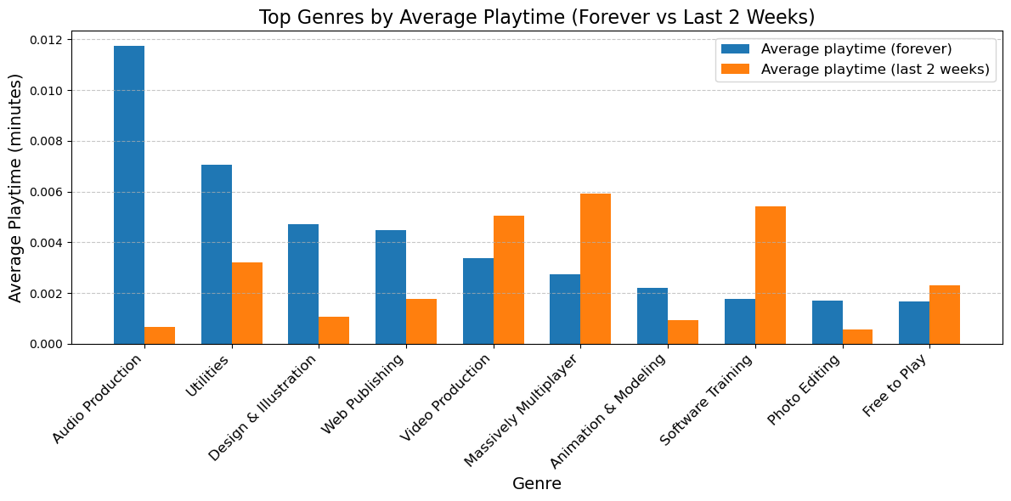

[Your explanation: 1. Purpose, 2. Methodology, 3. Explain the graph (e.g. what is x axis, what is y axis), 4. Harvest Highlights.]
- The purpose of this question is to see what genres of games and/or software have the highest playtime.
- I did this by first taking the data from the column “Average playtime (forever)” and “Average playtime (last 2 weeks)” and then determining the top 10 genres to plot them onto a bar graph.
- The bar graph in question has the x-axis as the genres, this includes the genres Audio Production, Utilities, Design & Illustration, Web Publishing, Video Production, Massively Multiplayer, Animation & Modeling, Software Training, Photo Editing, and Free to Play. The y-axis shows off the average playtime in minutes.
- For harvest highlights when we look at the graph the highest average play time is Audio production followed by Utilities for the Average playtime (forever), while the highest for Average playtime (last 2 weeks) is Massively multiplayer followed closely by software Training.
[Question2]: Are there common combinations of genres or tags that frequently appear together?
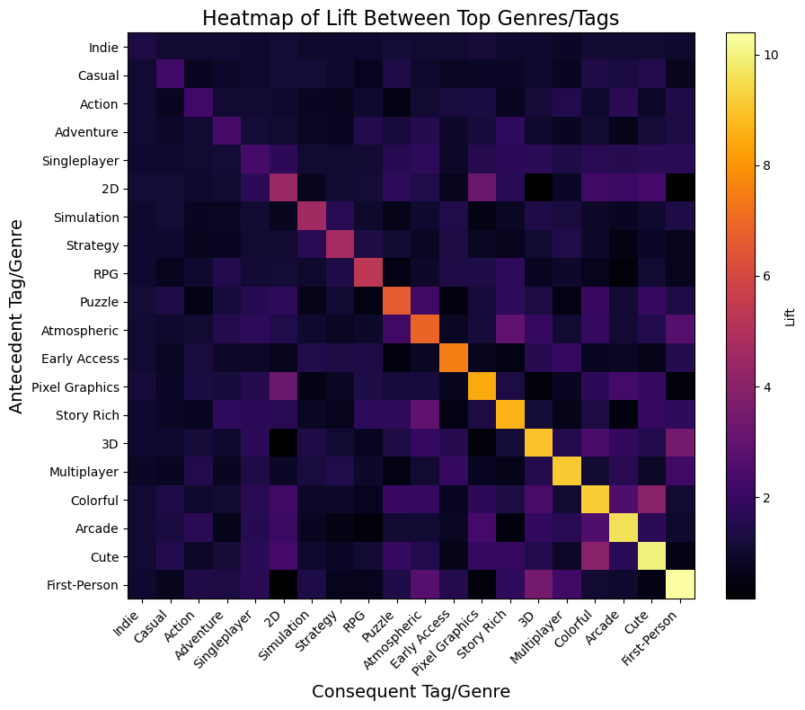
[Your explanation: 1. Purpose, 2. Methodology, 3. Explain the graph (e.g. what is x axis, what is y axis), 4. Harvest Highlights.]
- The purpose of this question was to determine what patterns with genres/tags show up when they are paired together.
- To do this I listed the top 20 tags on the steam dataset sorted by most used and then used the association rule to compare them to each other.
- The visual I ended up choosing to display the results was a heatmap because in my opinion they look cool. The x-axis displays the Consequent Tag/Genre while the y-axis displays the Antecedent Tag/Genre
- Regarding the results, there are several situations in which the same 2 tags end up together, we also get to see other situations in which groups of tags tend to end up being used together. Some notable instances were the tags colorful and cute, 3D and First-Person, Pixel Graphics and 2D, and Story Rich with Atmospheric. One notable group of tags often being put together were Singleplayer with the tags First-Person, Cute, Arcade, Colorful, 3D, Story Rich, Pixel Graphics, Atmospheric, Puzzle, and 2D, these all being tags that are often put together with singleplayer games. Another notable instance of grouped tags was 2D with cute, arcade, colorful, and Pixel graphics.
[Question3]: Can we classify whether a game receives positive reviews based on its features? (utilizing Naïve Bayes and a Decision tree)
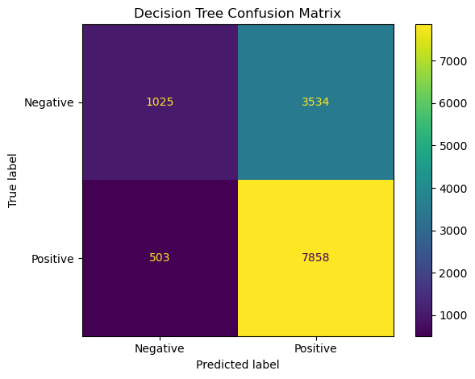
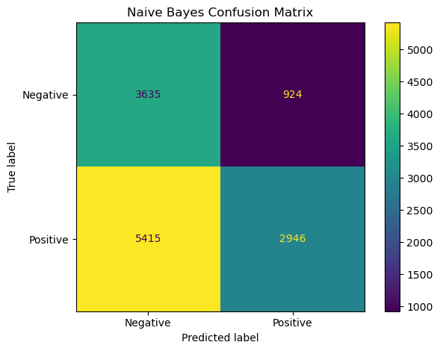
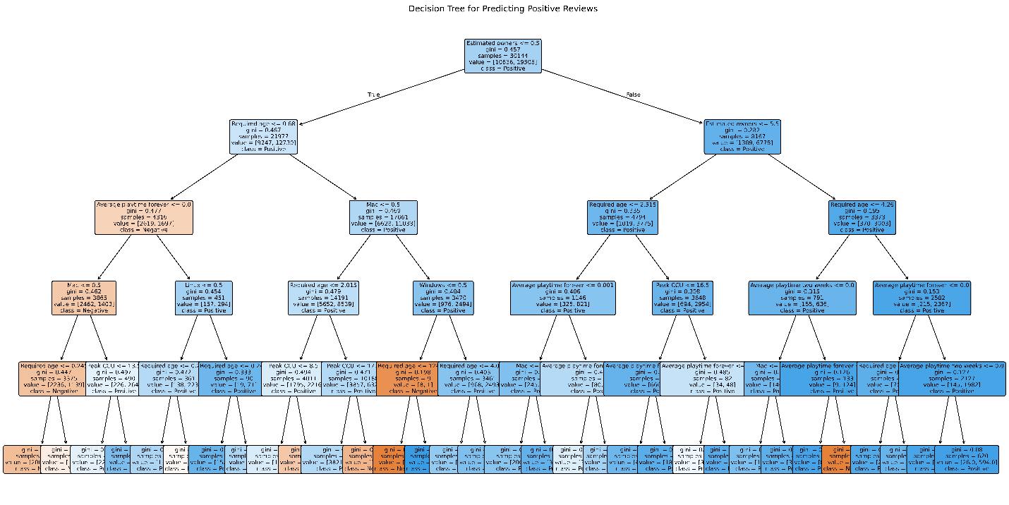
[Your explanation: 1. Purpose, 2. Methodology, 3. Explain the graph (e.g. what is x axis, what is y axis), 4. Harvest Highlights.]
- The purpose of this question was to see what factors might end up causing someone to leave a negative review on the game.
- In order to get the results of this question I first determined what features might affect someone’s chances of leaving a negative review, the features I chose were Price, Estimated Owners, Peak CCU, Required age, Average playtime forever, Average playtime two weeks, Windows, Mac, and Linux. After defining those features in the code I created a confusion matrix for the decision Tree and a confusion matrix for the naïve bayes algorithm to determine false positives/negatives. I then finally created the figure for the decision tree which ended up showing some pretty interesting results.
- Unfortunately the decision tree was pretty big so it’s a bit hard to see but that’s no big deal, obviously for the confusion matrix’s the x-axis’s are the predicted labels, and the y-axis’s are the true labels.
- Moving on to the results we can see that according to the decision tree there are a few instances that should be looked at. The first split is done via the feature “Estimated Owners”, and this is where we see the main changes when it comes down to positive or negative reviews. Mostly all the instances of negative reviews are on the side that has less estimated owners with the minor exception of the one orange rectangle on the bottom right. The next split to look at is done on the feature “Required Age” Now so far reviews have been mostly positive but after required age they seem to fall into the negative reviews, this is most likely due to age gated games typically having more thought put in to them along with the market of adults meaning that they actually have to put effort into their game or no one will play them. After required age is “Average Playtime Forever” This is where it starts dipping into the negatives, if it has a lower than average playtime it reaches a negative, it then moves onto support for mac, and Linux, if it doesn’t have support for mac it automatically turns negative, if it does it turns slightly more positive, however if it does have support for Linux the reviews turn really positive, but not too much negative if it doesn’t.
Regarding the Confusion Matrix’s, the decision tree leans heavily toward predicting “positive,” which increases true positives but also generates a high number of false positives. This suggests the tree may be biased toward the majority class or that the features used strongly correlate with positive reviews.
Naive Bayes is much more conservative. It avoids predicting “positive” unless very confident, which reduces false positives but causes it to miss many true positives. This suggests that Naive Bayes may not handle the feature distribution assumptions well for this dataset.

[Part2: Game Popularity and Player Engagement] for Alex Solomon
[Question4]: Which game genres have the highest and lowest average estimated owners?
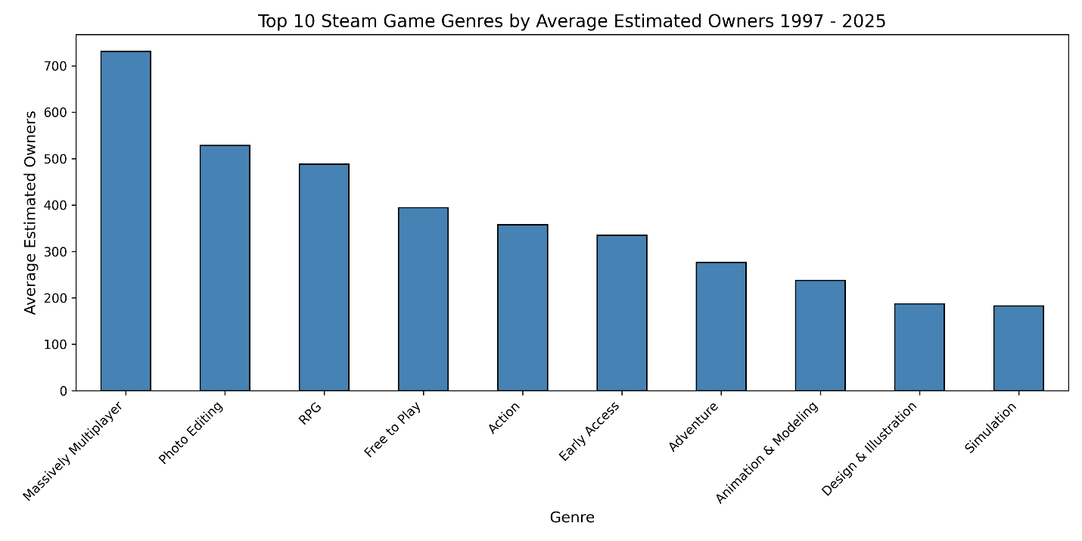
Top 10 Steam Game Genres by Ownership

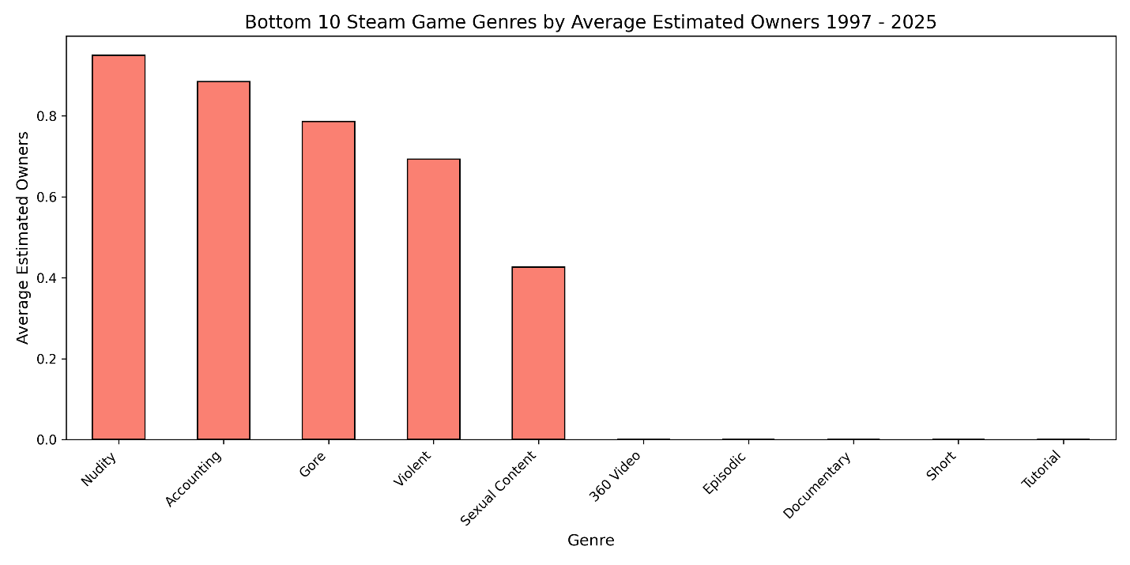
Bottom 10 Steam Game Genres by Ownership

1. Purpose: The purpose of this first analysis was to determine which Steam game genres attract the most players by average estimated owners. By finding both the highest-performing and lowest-performing genres, we can estimate which genres are most sought after (potentially profitable to market to), and which genres are more likely to perform poorly.

2. Methodology: To analyze genre popularity, the dataset first had to be cleaned so that each game’s genre information could be processed consistently. The raw dataset had genres stored as strings, so I converted these values into Python lists and removed empty or badly formed entries. After cleaning, I had to split the DataFrame so that each genre appeared in its own row, allowing every game to contribute just one record per associated genre. This was so games that fell under multiple genres could be measured as a separate entity per genre. This restructuring made it possible to analyze the genres independently!

Next, I grouped the expanded dataset by the “Genres” column and calculated the average estimated owners for each genre. This produced a list of genres along with their mean ownership counts. Lastly, I sorted these results in descending and ascending order to identify the top ten and bottom ten genres. I then visualized the results using bar charts to show the differences in player reach among different genre categories.

3. Explain the graph(s) (e.g. what is x axis, what is y axis): The first chart shows the top 10 Steam game genres ranked by average estimated owners. The X-Axis is Genre Names, The Y-Axis are the Average Estimated Owners. Each bar represents how many players on average own games in that genre. The first chart shows that the genres with the highest suggested player reach are “Massively Multiplayer”, “Photo Editing”, and “RPG.”

The second chart shows the bottom 10 Steam game genres ranked by average estimated owners. The X-Axis is Genre Names, The Y-Axis are the Average Estimated Owners. Each bar represents how many players on average own games in that genre. The bars in this chart are much shorter than the first, and suggest that genres like “Tutorial”, “Short”, and “360 Video” have extremely small/limited player bases.

4. Harvest Highlights: The results of my analysis show a big difference between most and least popular Steam game genres. We see that genres Massively Multiplayer, Photo Editing, RPG, and Free to Play games have higher average estimated owners according to this dataset. This suggests that games categorized as any of these are likely to have a stronger audience reach. On the other hand, our results suggest that genres like Tutorial, Short, Documentary, or 360 Video have much lower ownership averages. These are likely to have smaller or even niche audiences. Overall, these results help developers narrow down target game genres for greater visibility and market success!

[Question5]: Can group Steam games meaningfully based on price, playtime, and review activity? (K-Means)
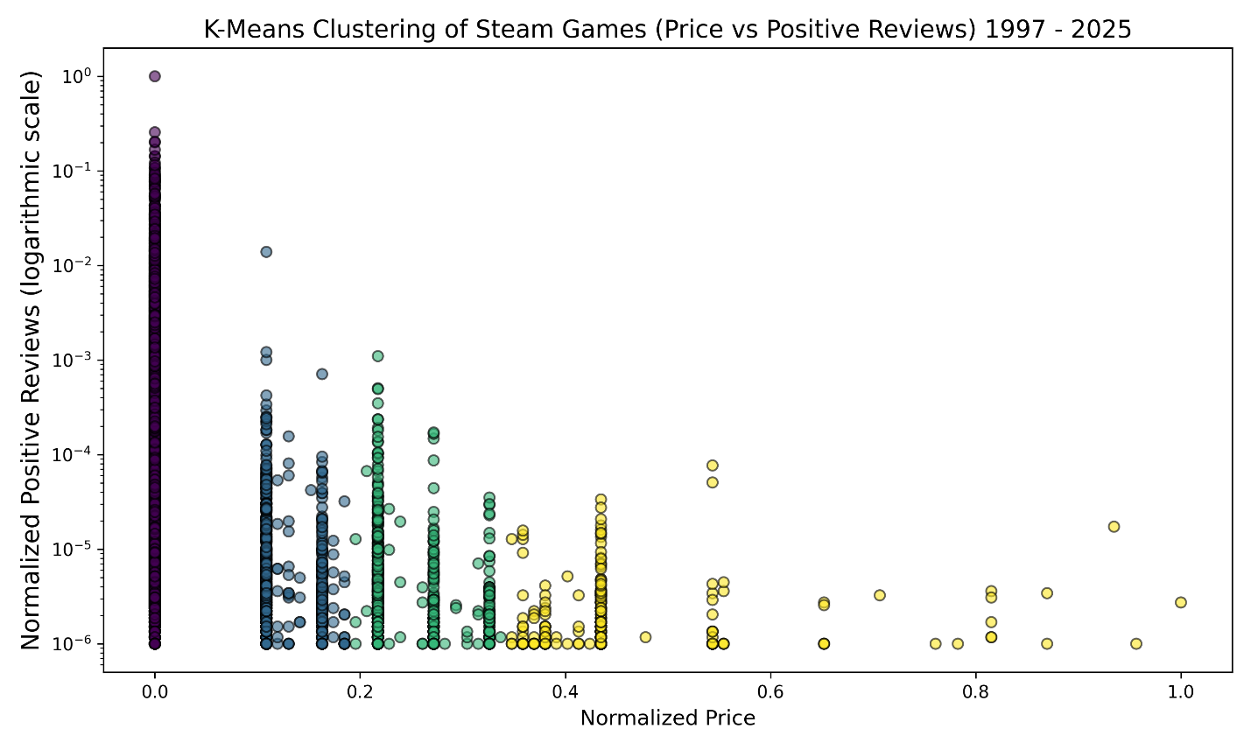
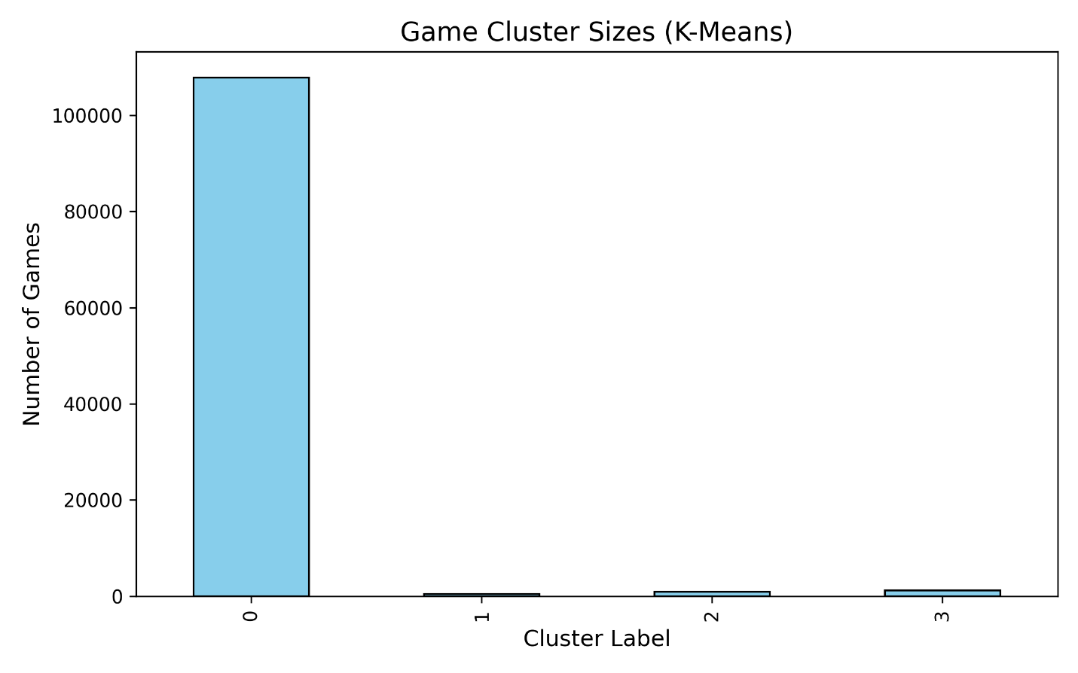

1. Purpose: The purpose of this analysis was to determine whether Steam games in this dataset could be grouped meaningfully by categories such as price and player engagement. I applied K-Means clustering to numeric features with the aim of discovering groups in the dataset, such as clusters of games with low-engagement, mildly successful games, or titles with higher prices. The goal of this was to help understand patterns in the Steam game market and how features like price affect player interaction with certain game types.

2. Methodology: Before I did any clustering, I first picked relevant numeric features in the dataset. These were already normalized when we cleaned up the dataset before any analysis. I made a new copy of the dataframe for this analysis to avoid disrupting the original. I applied K-Means using 4 clusters. I then fitted the model with the chosen data. I used a scatter plot to visualize the results, and a bar chart to better show the cluster sizes. Each cluster is represented by a different color.

3. Explain the graph (e.g. what is x axis, what is y axis): This analysis produced two visuals. The cluster scatter plot has the X-axis as the normalized game price, and the Y-axis as the normalized positive reviews is logarithmic scale to better display the heavily skewed data. The clusters differ by color. The bar chart’s X-axis are the cluster labels. The Y-axis are the number of games in each cluster. The bar chart helps us appreciate how many games belong to each cluster. We can see that the first cluster dominates because there are a lot of low-engagement games in this dataset.

4. Harvest Highlights: The results of this analysis show a big skew in this Steam dataset. One cluster has most games representing lower priced or free titles with very high player engagement. The other three clusters represent clusters of higher player engagement or prices and make up much smaller parts of the dataset. We can conclude from this that most of the steam games in this dataset get very little overall player interaction. Only a few categories show higher player engagement.

[Question6]: Which features correlate most strongly with estimated owners? (Correlation matrix)
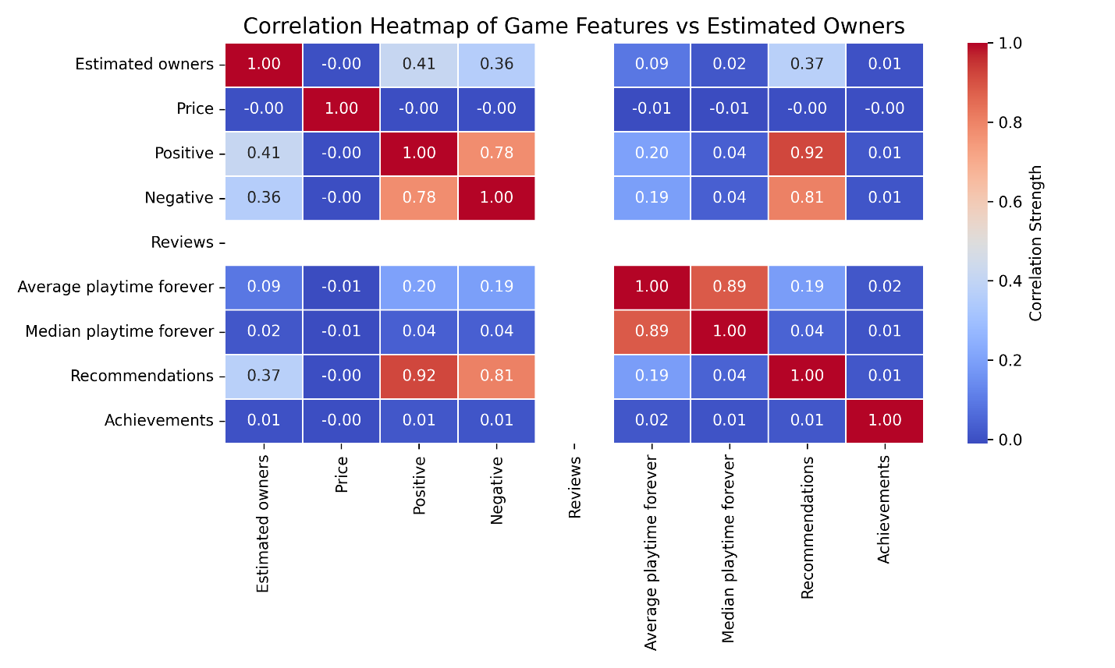

1. Purpose: The reason for this analysis was to see if we could find which game features correlate the most to estimated game ownership. For this, I chose to use estimated owners, price, positive reviews, negative reviews, total reviews, average playtime, median playtime, recommendations, and achievements. The missing values were filled with zeros to make sure we had a complete dataset. Slightly more cleaning was needed for this.

2. Methodology: Like the previous K-means analysis, I started with a new copy of the cleaned dataframe using only the selected features I listed in purpose. I computed the correlation matrix using the .corr() function in the Pandas API. I then plotted the results using a heatmap from the Seaborn API.

3. Explain the graph (e.g. what is x axis, what is y axis): Our X-axis are numerical feature names, and our Y-axis is the same. Darker red indicates strong positive correlation, light blue indicates weak or negative correlation, and white is none or nearly no correlation. The reviews column in our dataframe is actually populated entirely with NULL values, and this all squares are white.

4. Harvest Highlights: In our heatmap, the tiles corresponding to positive reviews, recommendations, and negative reviews display the strongest red coloration against the “Estimated owners” row. This supports that these specific features are the most influential predictors of game ownership. In contrast, features like price, achievements, and playtime appear in pale or neutral colors, showing weak or minimal correlation. This makes it easy for us to distinguish which attributes meaningfully impact Steam game ownership patterns and which contribute little to predicting game popularity.

[Part3: Stream Data Mining Analysis] for Diego T.
[Question7]: Does the consistency of game reviews change across pricing tiers? (Using review activity for min, max, and mean comparison)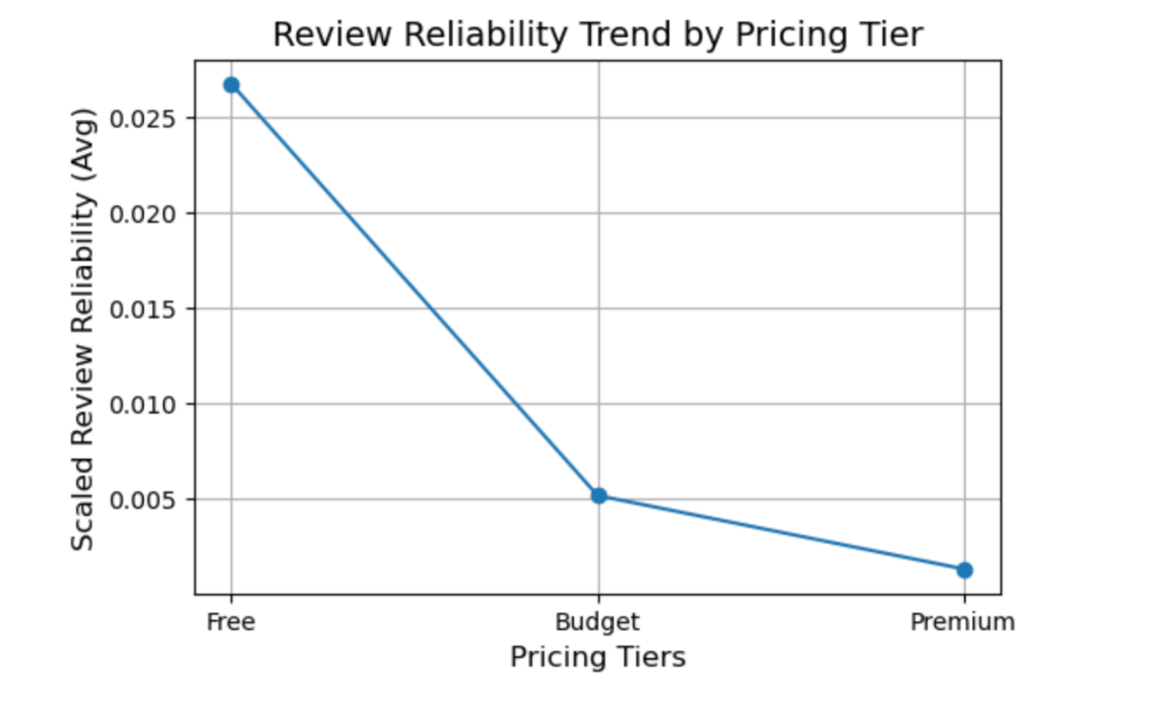
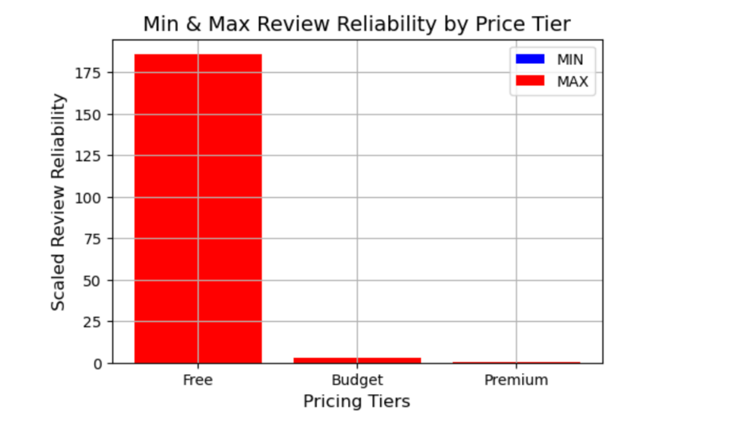

1. Purpose
The purpose of this question is to evaluate whether review participation behaves consistently inside each pricing tier rather than just identifying which tier has more reviews. Since the dataset includes games with extremely large, very small, or missing review communities, measuring the minimum, maximum, and mean review reliability helps reveal if a pricing group is dominated by outliers or shows balanced engagement. This insight matters for data mining because unstable review behavior in a tier can impact how credible or representative patterns are when building classification or association models later in the project.

2. Methodology
First, I created a review reliability metric directly from the dataset by adding the number of Positive and Negative reviews for each game into one total review activity score. This gives a single numerical value to represent the size of a game’s review community. Since review counts varied a lot between games, with some having extremely high amounts while others had almost none, I scaled the reliability score by multiplying it by 100 to make the values easier to visualize and explain.
Next, I rebuilt the pricing tier labels using the normalized Price column, grouping games into Free for titles priced at 0, Budget for lower-priced games, and Premium for the higher-price range. Once all games were assigned to a tier, I used grouping to calculate the minimum, maximum, and mean reliability value inside each pricing group. These summary statistics let me compare both review engagement and consistency across the different economic buckets in the data. Finally, for visualization, I plotted two charts—one line chart showing the trend of average reliability when moving from Free to Budget to Premium, and one bar chart showing the min-to-max reliability range inside each tier so I could analyze how spread out or stable each review community behaves when price changes.

3. Explain the graph (e.g. what is x axis, what is y axis):
Both graphs use the same pricing tier system to keep the analysis aligned. In the line chart titled “Review Reliability Trend by Pricing Tier,” the X-axis represents three groups: Free, Budget, and Premium games, and the Y-axis shows the scaled average review reliability, which was calculated by adding Positive and Negative reviews together and multiplying by 100. Each point on the line tells me the average size of a game’s review community at that price level. The key idea when reading this chart is that higher points mean stronger review engagement on average, which helps show whether players are actively leaving feedback in each tier.

In the bar chart titled “Min & Max Review Reliability by Price Tier,” the X-axis is again the three pricing tiers, but the Y-axis shows individual scaled reliability scores rather than averages. The MIN bar shows the smallest review community in each tier, and the MAX bar shows the largest. I look at the gap between the bars to understand review stability, meaning how consistent or unpredictable the review activity is inside each tier. When the gap is large, like in the Free tier, it means some games have massive review counts while others have almost none, creating more noise in reliability. When the gap is tighter, like in Budget or Premium games, it means review engagement is more consistent across titles. Together, these graphs help me explain not just how many reviews games get, but how far review behavior stretches inside each price bucket, which matters when judging credibility and stability in review patterns.

4. Harvest Highlights:
Looking at the graphs, I realized a few important things about how pricing connects to review reliability. Free games tend to have the largest and most active review communities because there’s no cost stopping players from trying them, which naturally leads to more feedback being left. That said, the Free tier also has a massive MAX value, meaning a small handful of free games receive extreme attention and dominate the review space. This made it clear that even though free games score highest on average for reliability, their review activity is very unbalanced. The spread between the MIN and MAX values shows that many free titles barely receive reviews at all, while just a few take almost all the engagement, which creates a lot of noise in the data.
On the other side, Budget and Premium games show smaller ranges and lower peaks, but their review behavior is way more stable and predictable. They don’t explode into massive outliers like the Free tier does, but they also don’t fall into empty review patterns nearly as often. In the end, this helped me understand that price affects not only how large a review community becomes, but also how even, consistent, and credible the participation inside those groups really is. Free games generate the biggest spikes, but paid games keep things more steady, making their review reliability easier to trust when analyzing overall patterns.

[Question8]: Do Steam games form natural price-review clusters when grouped by similarity? (K-Means + Silhouette score evaluation)

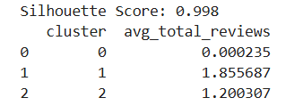
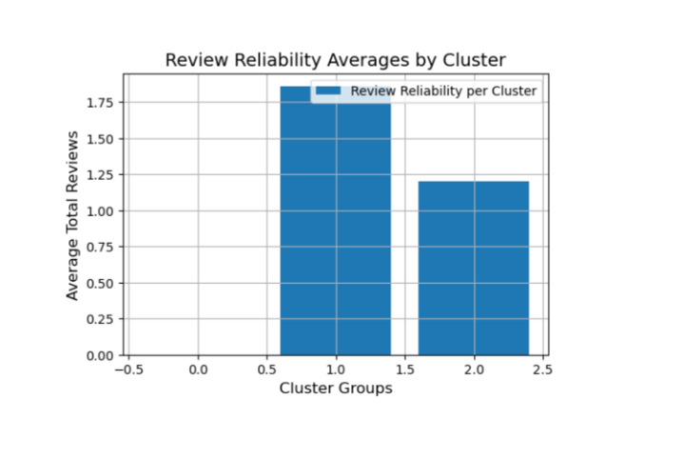

1. Purpose
The purpose of this question is to determine whether meaningful review communities naturally emerge among Steam games when grouped using similarity in price and review activity. Since some games have huge reviewer engagement while many others have very few or no reviews, this analysis tests whether price similarity is strong enough to structure review behavior into natural segments, not just arbitrary price splits. The goal is to validate whether review participation forms into real communities that share patterns rather than being scattered randomly across all titles. This matters for data mining because understanding cluster structure helps us know if pricing is a potential driver behind how users review games and how trustworthy those segments might be for later predictive modeling.

2. Methodology
To approach this, I built on the cleaned dataset already loaded in the notebook and used a large reproducible sample to avoid performance issues while still capturing meaningful variation in the data. I selected the normalized Price, Positive, and Negative review columns as clustering features and standardized them so that distances between games were fair and balanced. This step ensures that no single feature dominates solely because of scale differences. Then I applied K-Means clustering to form natural price-review segments based strictly on similarity found in the actual dataset, not manual grouping decisions. After clusters were created, I evaluated their quality using the Silhouette score, which measures how tightly packed games are within a cluster and how well separated each cluster is from the others. Finally, I visualized the review reliability cluster averages using the bar and line charts we covered in class and interpreted how reliable or noisy the review behavior is inside each cluster segment.

3. Explain the graph (e.g. what is x axis, what is y axis):
The X-axis represents the cluster IDs generated by the K-Means model, meaning each data point is part of a natural similarity-based segment discovered from the dataset. The Y-axis represents the average scaled review reliability inside each cluster, calculated earlier as Positive + Negative reviews multiplied by 100 for readability. When reading this graph, higher Y-values mean the average game inside that cluster belongs to a more centralized and active review community, while lower Y-values show clusters grouping many low-engagement or sparse-review titles.

The spread between cluster heights helps show review structure and stability inside similarity-based groups, and the Silhouette score included above the visual confirms that the clusters formed are meaningful and not simply random price tiers. The final cluster validity means that even though the dataset includes a lot of 0 reviews, clustering still revealed a real pattern in how review participation organizes itself when price and behavior are similar. This structure gives confidence that at least one review community is naturally more engaged and reliable, while most games land in clusters with lower participation. The big idea here is that pricing similarity impacts how review communities form, and this segmentation shows internal structure beyond assumptions.

4. Harvest Highlights
The clustering results showed that Steam games do form natural review groups when segmented by price-review similarity, confirmed by a strong Silhouette score that proves the model created structured separation even with uneven data. Most games are clustered into groups with smaller or inactive review sizes, which suggests that review participation is not equally balanced across all titles. Only a few clustered segments show major concentrated review communities, while others capture most sparse engagement games. This confirmed for me that even in messy semi-structured data, similarity-based clustering still reveals real community review behavior shaped by price patterns, not randomness.
[Question9]: What is the strongest interaction rule between game platforms and tags in the dataset?
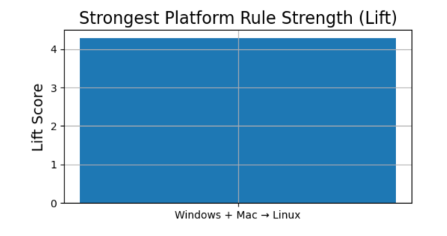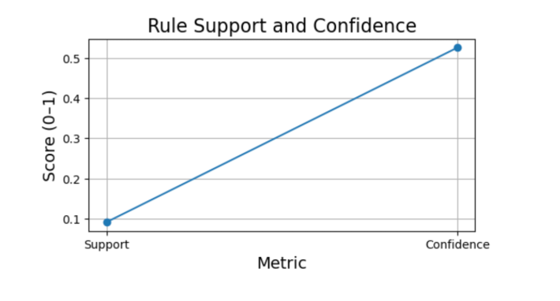
1. Purpose
The purpose of this question is to discover whether strong behavioral links exist between the platforms a game supports and the descriptive tags it receives from players. Instead of assuming popular genres or big publishers drive the patterns, this analysis looks for less-obvious relationships that emerge from platform accessibility itself. By finding the strongest association rule, we can understand if certain systems naturally link to specific tag communities, meaning players label games differently depending on what platform they run on. This matters because strong interaction rules help identify patterns, we don’t immediately notice by scanning the table alone, and it can guide both recommendation features and future data segmentation. It also helps to validate whether tags are tied to platform ecosystems or random noise.

2. Methodology
To approach this, I started by converting the Tags column into transactions, where each tag became its own entry so patterns could be counted instead of treated like long raw text. Then, I encoded the platform columns — Windows, Mac, and Linux — by turning True/False into 1 and 0 so the algorithm could measure relationships in the same table as tags. Next, I used the Apriori algorithm from mlxtend to generate frequent item sets, which basically means finding which platform–tag combos show up most often together. After that, I built association rules and compared them using lift, confidence, and support to decide which ones are strong and trustworthy.
The rule with the highest lift score was selected because lift tells us how much stronger the pattern is compared to pure chance. The strongest relationship turned out to be Windows + Mac → Linux, meaning games that ran on both major platforms were way more likely than expected to also include Linux support. This suggests a real ecosystem-level pattern, likely tied to how cross-platform developers ship their games. Finally, I visualized the rule strength using a bar chart for lift comparison and a line chart to show support vs confidence, so the results were easier to explain visually.

3. Explain the graph (e.g. what is x axis, what is y axis)
The first chart, titled Strongest Platform Rule Strength (Lift), has a single grouped bar on the X-axis that says Windows + Mac → Linux and the Y-axis labeled Lift Score. The Lift Score measures how strong a rule is compared to random chance. Since this bar reaches above 4, it tells me the rule is over 4× stronger than what would happen if platform support and tags were unrelated. In other words, this means the relationship is very real and not accidental — games that support both Windows and Mac tend to include Linux support way more often than expected.
The second chart, called Rule Support and Confidence, compares the rule’s support and confidence. The X-axis shows the two metrics side-by-side, and the Y-axis shows their normalized scores from 0–1. Support means how often the full rule (Windows + Mac + Linux together) appears in the dataset, while confidence tells me, out of all the games that support Windows and Mac, how many also support Linux. The fact that confidence is much higher than support and trending upward shows that even though Linux support doesn’t appear super often overall, when both major platforms are present, Linux support usually follows. Taken together, the visuals help me explain two things clearly: the rule is statistically strong (high lift), and it reliably predicts Linux support when Windows and Mac support are already there (high confidence). This lets me talk about rule strength and reliability without relying on averages or vague observations.

4. Harvest Highlights
From this chart, I learned that platform support has a surprisingly strong connection to certain tag structures in the dataset. The rule showing Windows + Mac → Linux had a lift above 4, meaning that when a game supports both major platforms, Linux support becomes way more than expected by chance alone. Even though only about 17% of all games in the sample shared that platform bundle, more than half of the Windows–Mac games also carried Linux-related tags, which made the rule reliable when it appeared. This showed me that strong review-community behavior isn’t only tied to genres or publishers—platform overlap itself can signal real developer patterns and shape tag communities. The charts made it easier to explain that some platform combinations are powerful indicators of tag structure and community size, which is important to understand before applying classifiers or recommendations to the dataset.
Overview
Main Finding 1
The heatmap analysis showed that Steam tags and genres form repeated, non-random pairings, meaning there are clear theme clusters in how games are labeled. The strongest co-occurring combinations included Colorful + Cute, 3D + First-Person, and Pixel Graphics + 2D, which appear frequently across many titles. The data also showed that Single-player games create the biggest tag ecosystems, consistently linking to First-Person, 3D, Cute, Arcade, Colorful, Puzzle, Atmospheric, and 2D tags. Overall, this tells me that Steam labeling behavior favors predictable tag bundles based on game design style and play mode, not isolated tags.

Main Finding 2
A second main finding from the Steam dataset is that review participation is the strongest signal of ownership scale. Using feature correlation, Positive reviews, Recommendations, and even Negative reviews showed the highest correlation with Estimated owners, meaning games with more reviewer activity generally have higher ownership estimates, regardless of sentiment. Price, Achievements, Average playtime, and Median playtime showed almost no meaningful correlation, and the mostly empty Reviews column added no predictive value. This helped confirm that ownership trends on Steam are driven more by visible review and recommendation activity than by cost or playtime behavior.

Main Finding 3
The third main finding from the Steam dataset is that cross-platform support forms a predictable ecosystem-level rule for tags, not random noise. The rule Windows + Mac → Linux had the highest lift and confidence, showing that games built for both major systems are far more likely than expected to also ship with Linux support. This means the association is multiple times stronger than chance (high lift) and reliably predicts Linux tagging behavior when the other two platforms are present (high confidence). Overall, this suggests that Linux-tag communities emerge as a natural follow-through effect of developer platform targeting, making it a meaningful interaction rule in the dataset.

Contributions
Isaac D.
I was responsible for handling the overall GitHub that we used to put everything together, this included making the GitHub repository, organizing the branches, adding the rest of the group as collaborators, and pushing/merging the final results everyone did into one cohesive file. I also did questions 1, 2 and 3, which mainly focused on game genres, tags, and features. I took on the role of leader for the group project making sure everything was on track to be uploaded and turned in on time, this also included making sure the project report was set up properly, creating the google slides so everyone can edit them properly and making sure the rest of the group had access to everything.
Alex S.
I was responsible for performing the initial dataset cleaning and preparing the data for analysis. This included handling duplicate rows, dealing with null values, normalizing numerical features, and converting mixed data types into consistent formats that could be used in our models. I also completed Questions 7, 8, and 9, which involved analyzing genre popularity, applying K-Means clustering, and performing a correlation study. One of the challenges I encountered was interpreting the initial scatter plot results during the clustering phase, as the heavy skew in the dataset made early visualizations difficult to read. However, by adjusting the scaling to logarithmic and reviewing the underlying data, I was able to resolve the issue and produce meaningful results.

Diego T.
My responsibility for this project is the statistical review-consistency analysis and the platform-tag association rule mining, including model evaluation and visualization. For clustering, I applied similarity-based segmentation using algorithms like K-Means and verified structure using silhouette scoring, while for associations I mined platform-to-tag relationships using Apriori rule modeling from the mlxtend library. The biggest challenge I faced was dealing with sparse and messy real-world data where many games contained zero or missing reviews, which caused memory errors and made it hard to visualize trends at scale. Another major hurdle was correctly transforming tags into transactions without overwhelming system memory, which forced me to research sampling strategies, data encoding, and model tuning more deeply. This process also required validating cluster effectiveness using metrics like the silhouette score to ensure the clusters formed were actually meaningful and not just random groupings. A key issue for me was understanding what rule-strength metrics like lift and conviction actually meant so I could confidently explain them, which took trial, error, and digging through the model logic.

